Sravani Sriramoju

Automation Engineer-EASi

/*Create a program that displays how many times a word appears up in a file, or across files. The program will be seeded with an input file where each line is another file’s relative path. Each file in the path will contain the words needed to be tracked. User should be able to run the program and see a list of all the words and their respective counts. The program will need to quickly handle 1000’s lines in the input file and display results in a timely manner*/

**Requirements for the program:**

Install Visual Studio 2019

Create an ASP.NET Core web application project. The project type comes with all template files to create a web app, before you've even added anything!

1. Open Visual Studio.
2. On the start window, choose **Create a new project**.

On the Create a new project window, enter or type *webform* in the search box. Next, Choose C# from the language list, and then choose windows from the platform list.

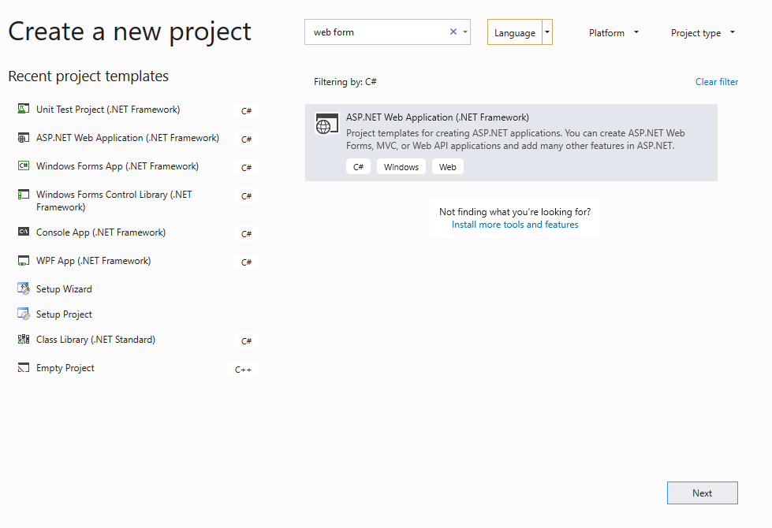

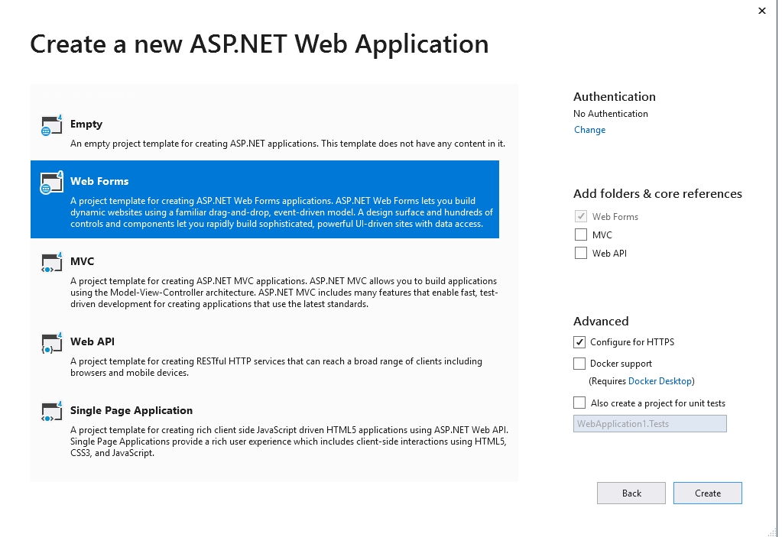

In the configure your new project window, type project name and then choose Create.

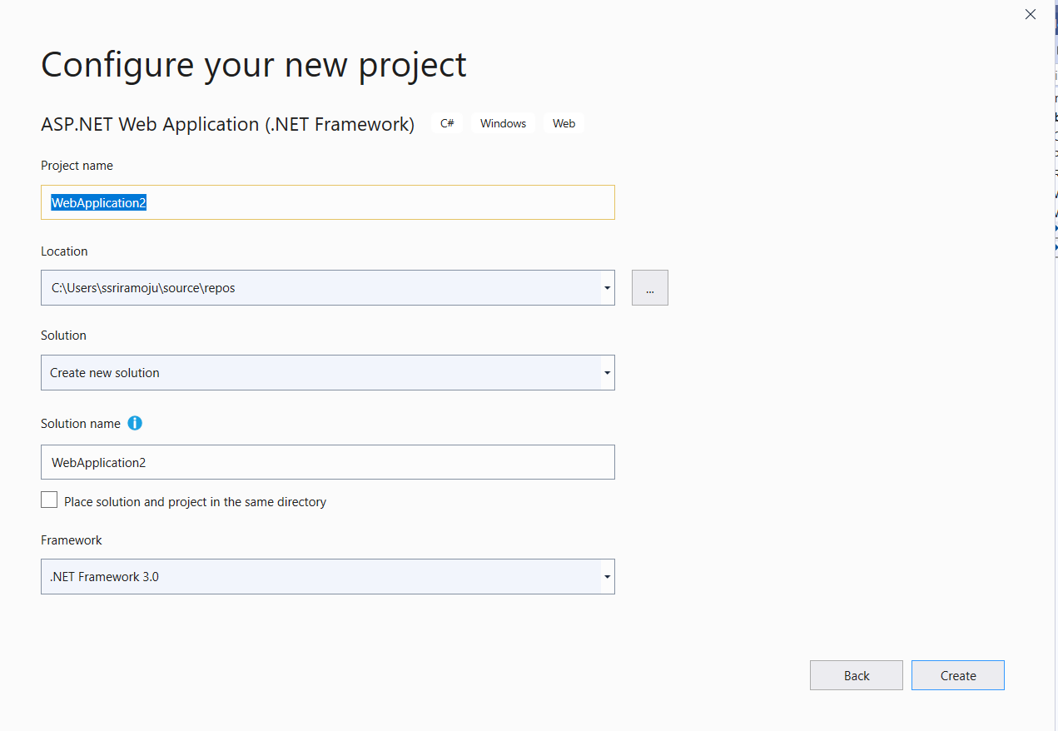

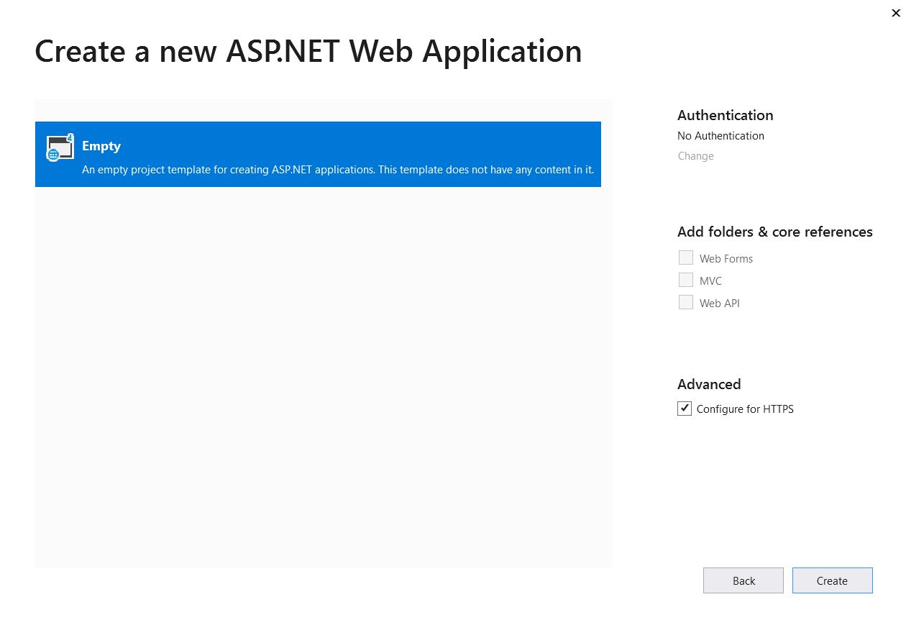

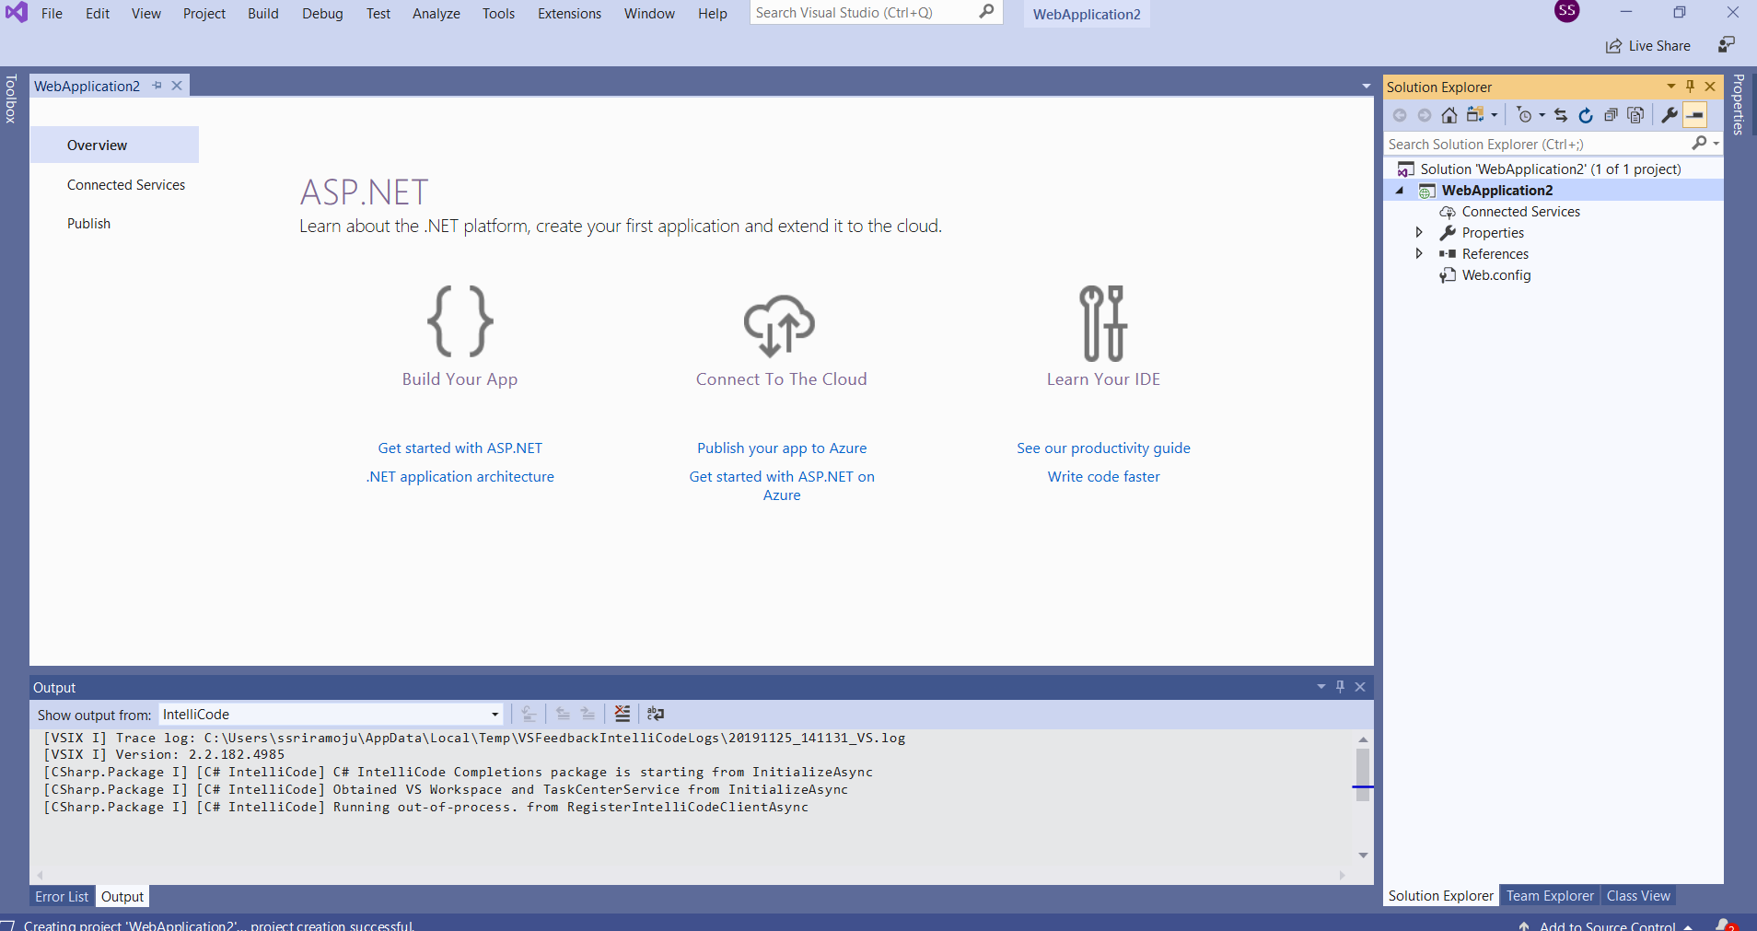

In the solution explorer, Right click on new Items and add a webform and click add.

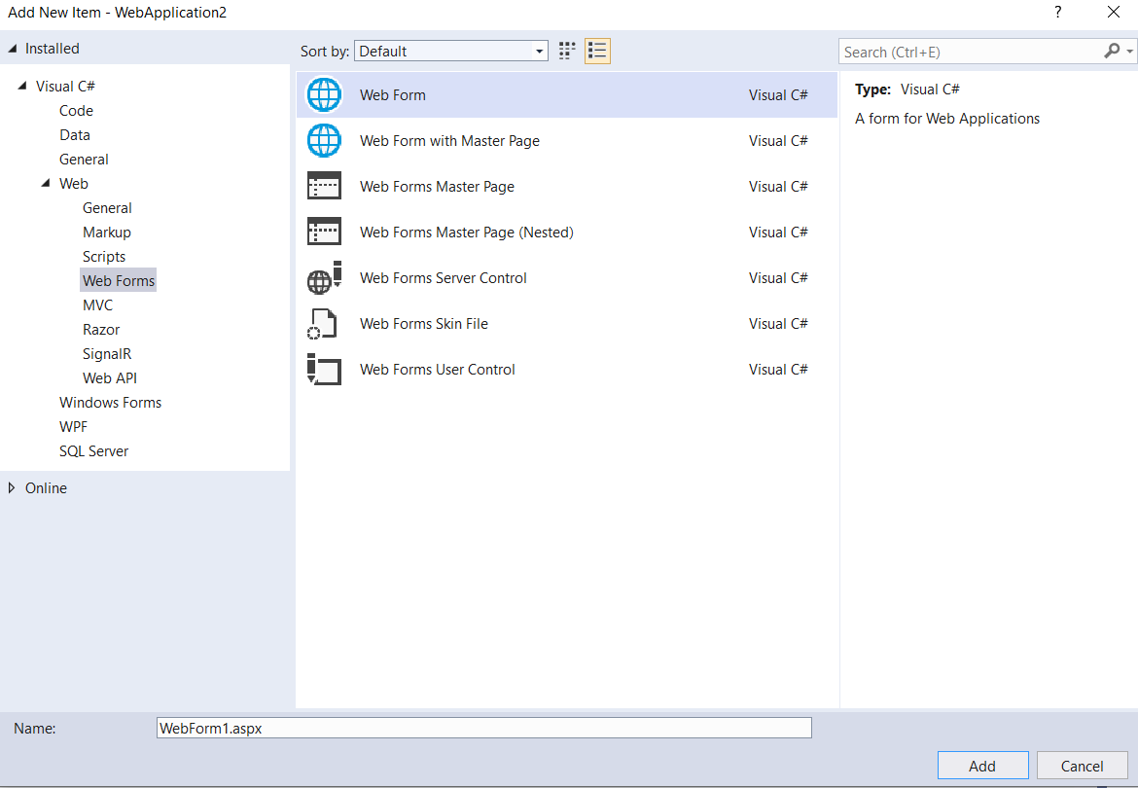

Using Toolbox, I have added panel , File upload ,label and textbox for searching word and button to upload. Double click on upload button and Add the logic for Upload_Click .

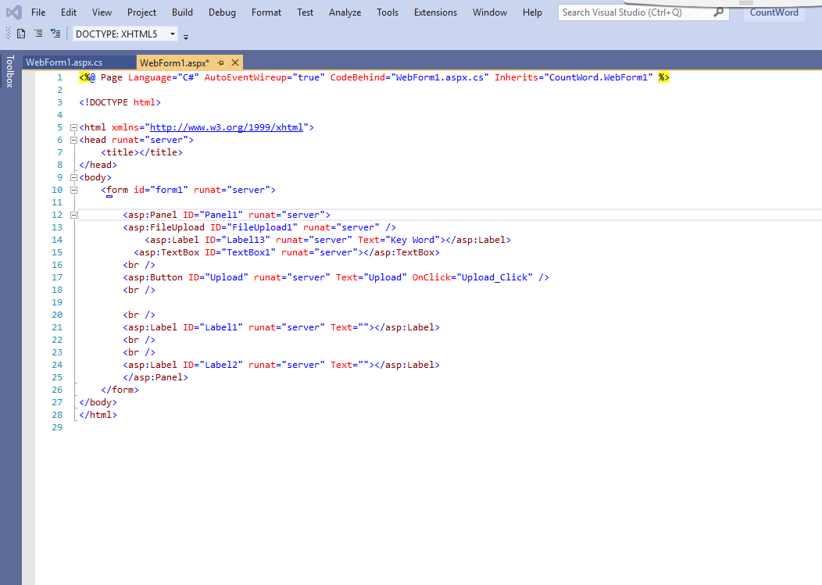

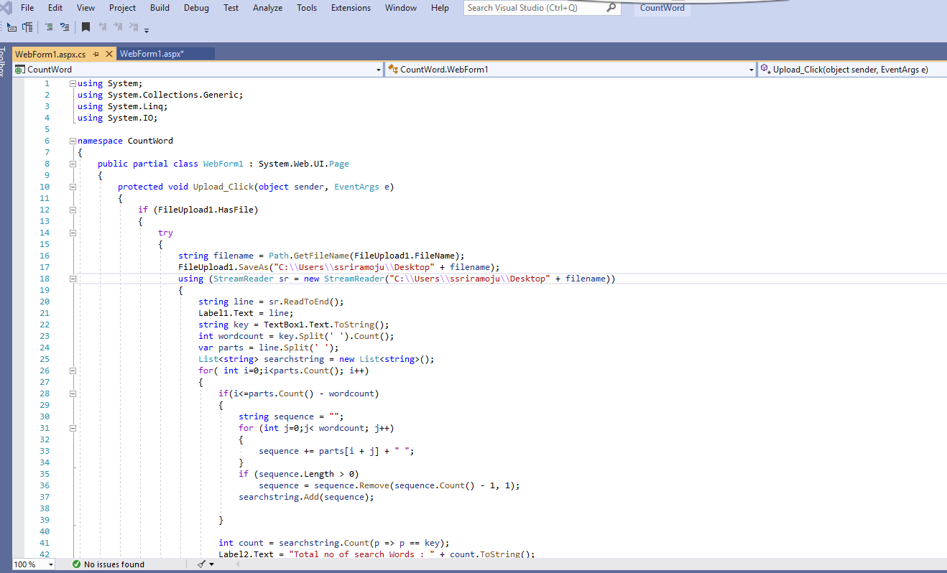

Create a text file in your local desktop and add the path in stream reader. Build the solution and run the app and see as below:

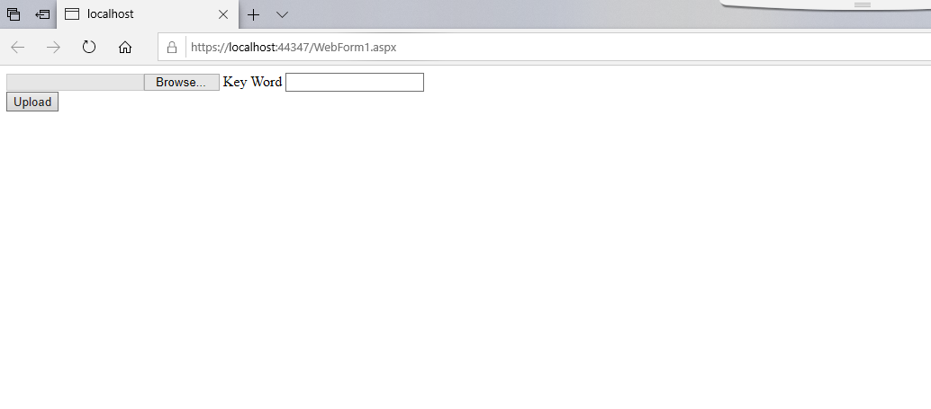

Upload the text file from the local machine and enter key word search and upload.

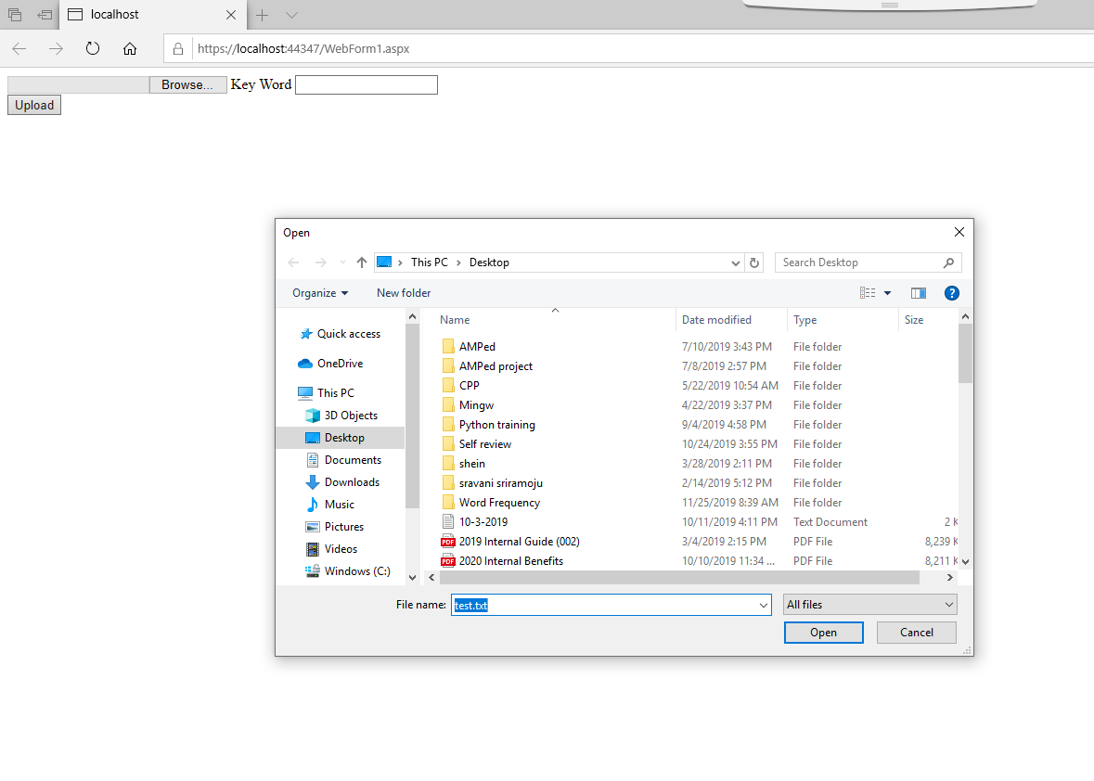 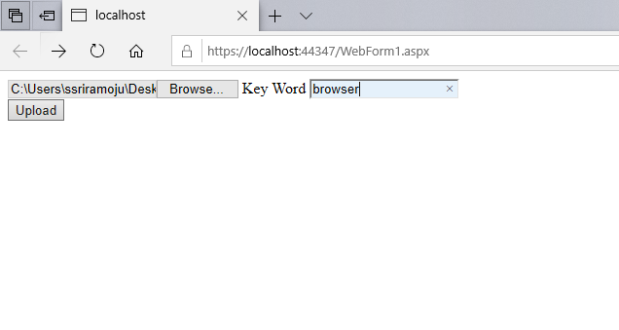

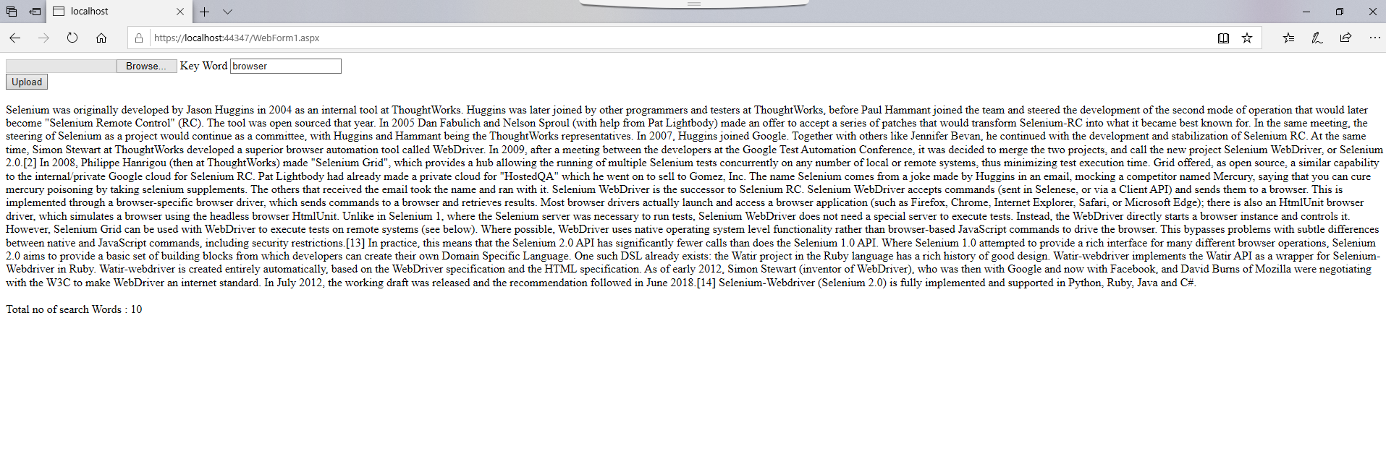

**Selenium Testing for the web application created above:**

Open Visual studio and create a Unit test Project and select C# from the language.

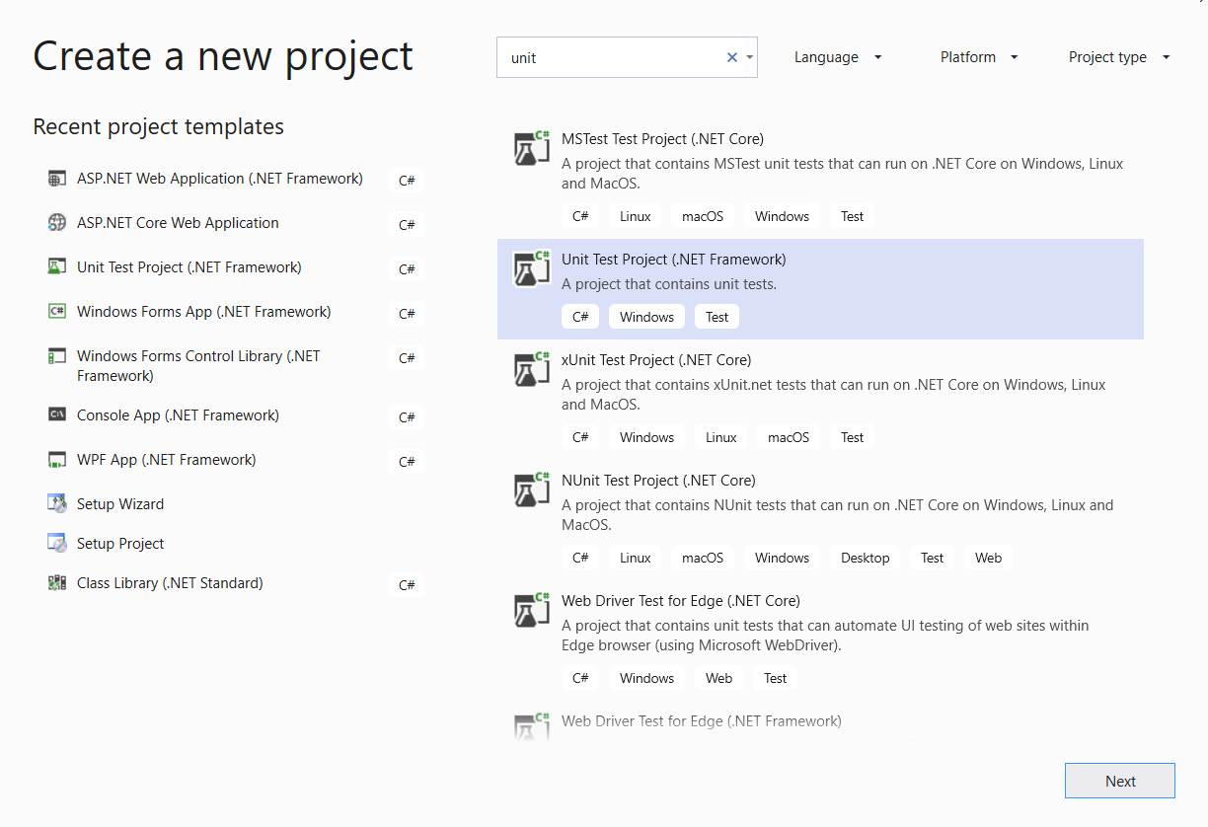

Configure the project with project name.

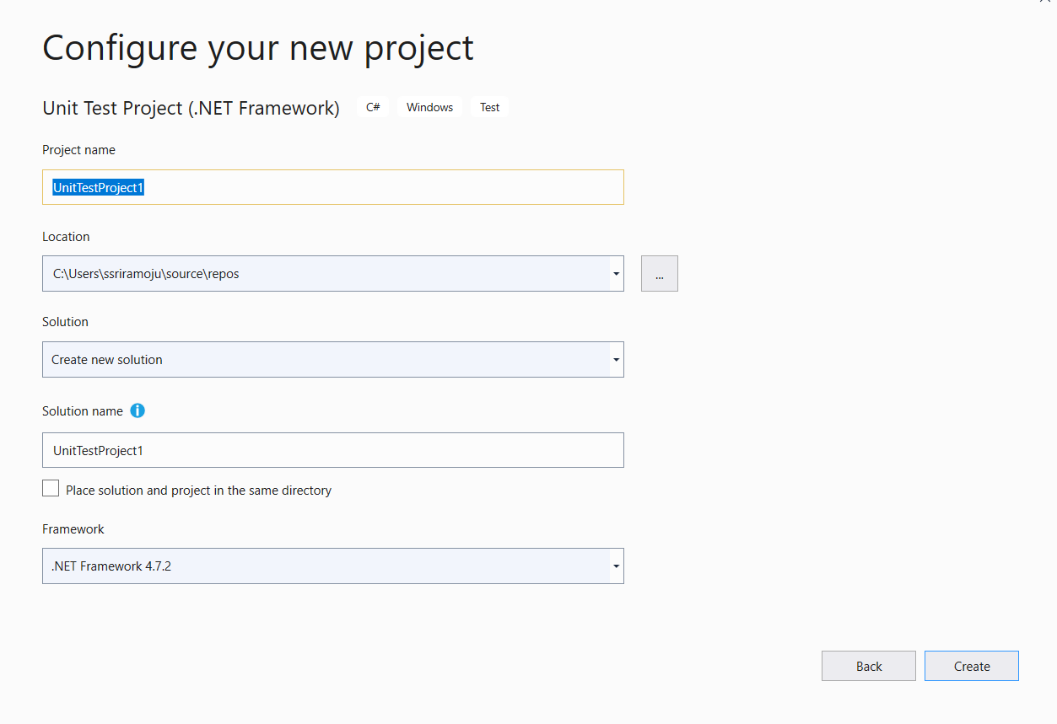

Go to project and click on “Manage NuGet Packages” and install frameworks and drivers “Nunit”,”Selenium.webdriver”,”Selenium.webdriver.chromedriver”.

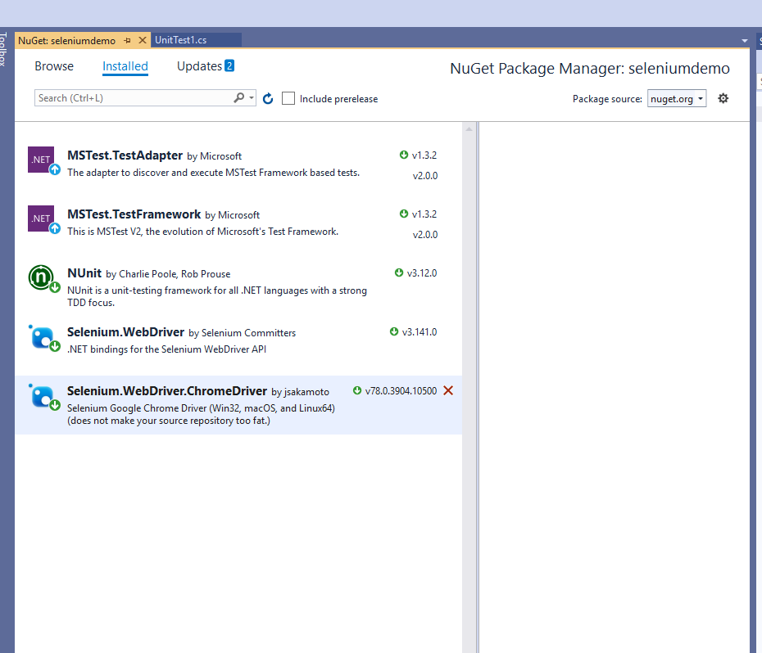

In the unittest.cs, add the following test method and run the tests. To the run the tests, web application has been in running mode. Inspect the elements using Id or Css selector or Xpath in chrome browser.

<https://localhost:44347/WebForm1.aspx>

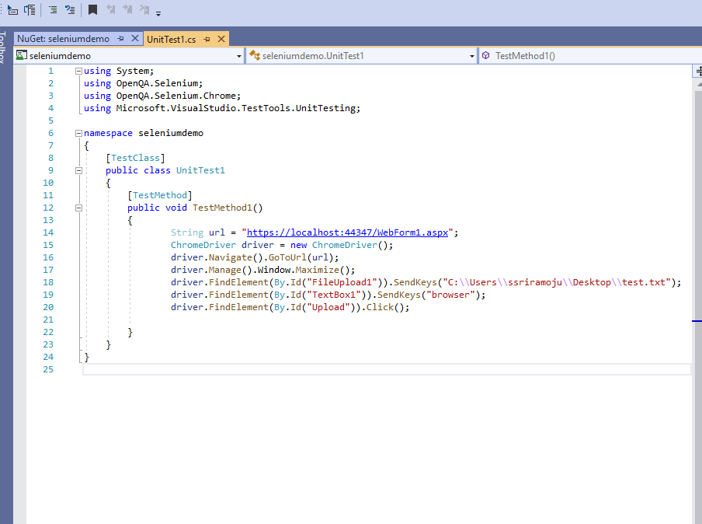

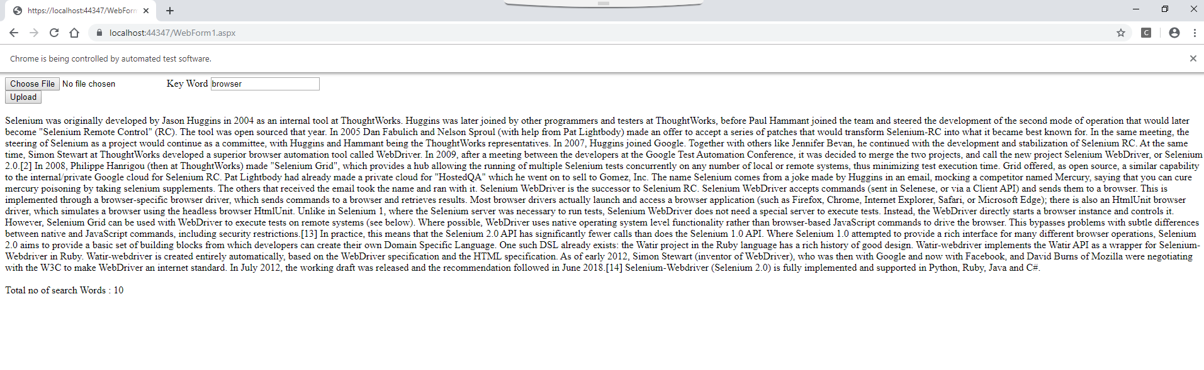

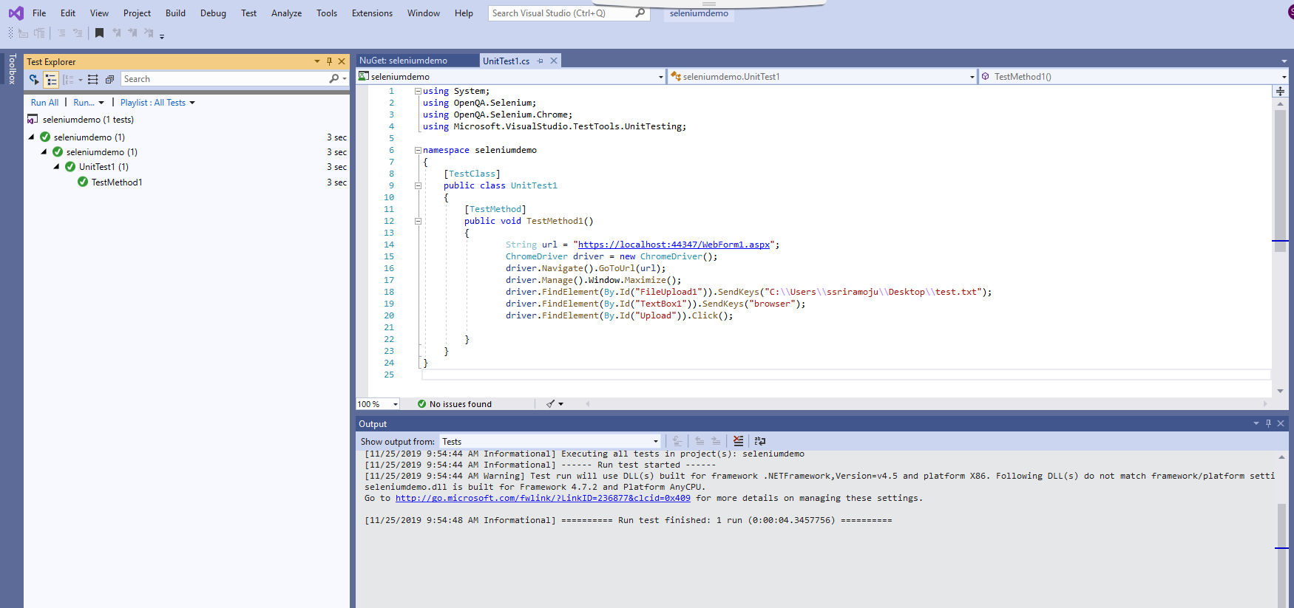

Thankyou!